**Great Basin Naturalists *at Galena***

**Air Quality Researchers**

C:\Users\CMIT\AppData\Local\Microsoft\Windows\Temporary Internet Files\Content.IE5\A3P1MEU3\MC900297985[1].wmfScientists learn about environmental conditions by collecting data. When there is a lot of data to collect over a big survey area, it is good to have a team of researchers. We are seeking your help in collecting data about air quality in the Truckee-Meadows and Northern Nevada. Below you will find instructions for setting up a particulate catcher at your home and then for reporting your finding back to Great Basin Naturalists *at Galena*. Once we have collected enough data, we will make it available to you.

What will we discover when we all work together?

**Setting up your particulate catcher**

1. Glue or tape particulate catcher template to a 3x5 index card
2. Fill in the blank spaces on your card
3. Select the place outside where you will place your card
4. If you will be hanging your card, punch a hole in the top and tie it with string
5. Using a popsicle stick, apply a thin layer of petroleum jelly to the outlined square on your card
6. Hang up or mount your card in the spot you chose
7. Take a photo of your card (optional)
8. Check on your card once a day to make sure it has not blown away or fallen from its spot

**Collecting your data**

1. Remove your card from the spot you put it
2. Record the date you removed the card, this will tell you how many days it has been up
3. With a magnifying glass, count the number of particles you see ***only*** within the square on your card
4. Record the number on your worksheet and note any other material stuck on the jelly in the square
5. Complete your worksheet and return it to the Galena Creek Visitor Center, or input your findings on your computer at the Home School Page on the Galena Creek Visitor Center website
6. Send a picture of your particulate catcher (optional)
7. We will notify you once enough data has been collected and you will be able to see the product of your work.

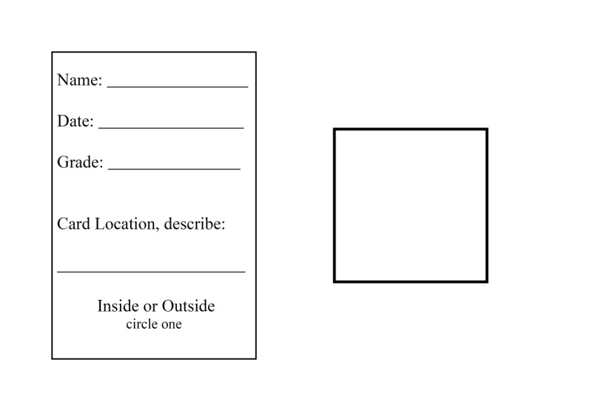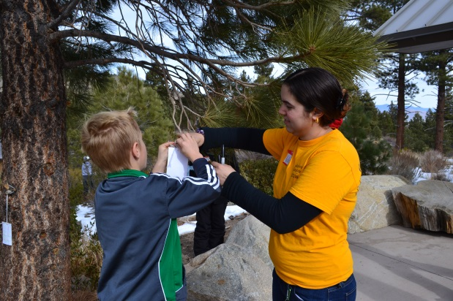

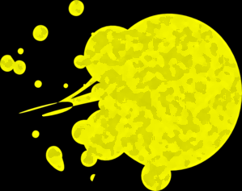

**petroleum jelly**