Galena Creek Exploration Field Trip Rules and Expectations
Calling all nature detectives! Gear up for an epic adventure at Galena Creek, but before we embark on our quest, let's crack the code to a super fun and safe expedition:

- Hiking Etiquette: When we hit the trails, stick close to our awesome Guide – they're the ultimate map and compass, leading us to hidden wonders and keeping us safe! Do not pass your Guide or people in front of you when hiking. When meeting other hikers on the trail we will pause and let them pass. Do not pet any dogs and keep hands to yourself while hiking.

- No Lone Wolves, Stay Close to Your Class: There will be times we go off the designated trail for a nature activity. Keep your teacher insight at all times and listen for time reminders when finishing an activity. If you need a pit stop, let your teacher know first – they're your adventure buddy!

- Respect the Wild Crew: We admire our furry and feathery friends from afar! No touching, chasing, or feeding them. After lunch clean up all food trash and make sure that park area is properly cleaned.

- Leave No Trace: Plants and rocks are part of the park's magic, so appreciate them without taking them home. Follow The 7 Ethics at all times. Please no don’t bang sticks on trees or break branches.

- Visitor Center Expectations: Inside the visitor center, unleash your inner detective! But instead of touching the taxidermy birds, be gentle with the displays. By respecting them, everyone can enjoy the park's history and explore these cool creatures. Feeling lost? Don't be shy to ask! There are no silly questions.

- Eagle Ears: Pay attention to your Guide and teacher's instructions – they are sharing important info to keep us safe and make the adventure legendary! Please do not talk when your Guide is speaking.

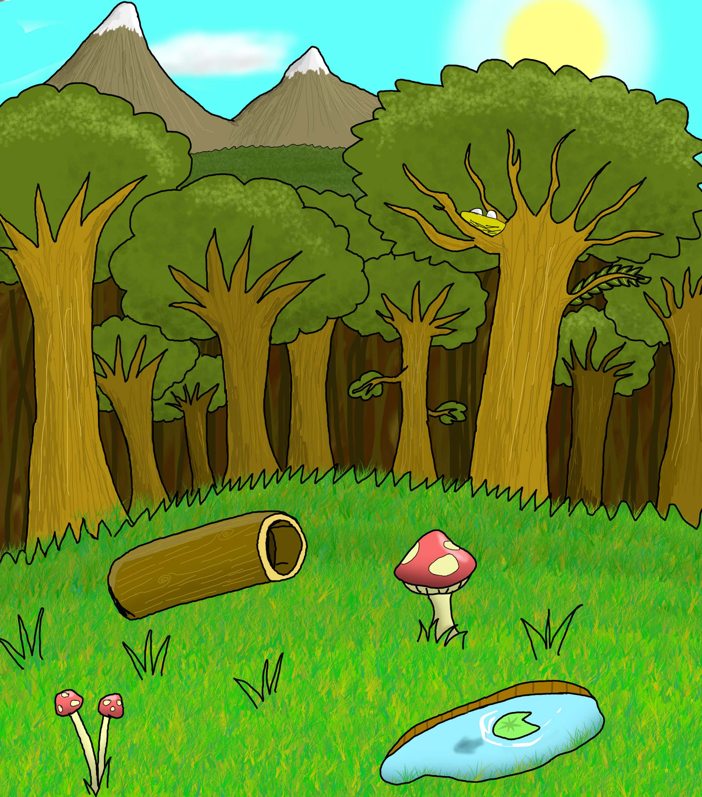
- Teamwork Wins! Share, take turns, and be kind to your fellow explorers. Together, we can make this field trip the most epic one ever!

